NAME: ZAMEER ALI TUNIO

HIDAYA ID: 17836

SHIFT: EVENING

DATE: 23/03/2022

1. SELECT * FROM student s INNER JOIN department d ON s.`dept_id`=d.`dept_id` WHERE d.`dept_name`='BS-SW';



2. SELECT * FROM student s INNER JOIN department d ON s.`dept_id`=d.`dept_id` WHERE d.`dept_name`='BS-CS';



3 SELECT * FROM student s INNER JOIN department d ON s.`dept_id`=d.`dept_id` WHERE s.`stu_name`='AHMED';



4 SELECT s.`stu_id`,s.`stu_name`,d.`dept_id`,d.`dept_name`,b.`batch_id`,b.`name` FROM student s

INNER JOIN department d ON s.`dept_id`=d.`dept_id`

INNER JOIN batch b ON d.`dept_id`=b.`dept_id`

INNER JOIN course_batch cb ON b.`batch_id`=cb.`batch_id`

INNER JOIN courses c ON cb.`course_id`=c.`course_id`

WHERE s.`stu_name`='NADIA' AND b.`name`='13TL';



5 SELECT * FROM courses c INNER JOIN teacher_course tc ON c.`course_id`=tc.`course_id` INNER JOIN teacher t ON t.`teacher_id`=tc.`teacher_id`

WHERE c.`course_name`='JAVA';



6 SELECT b.`batch_id`,b.`name`,C.`course_id`,C.`course_name` FROM

batch b INNER JOIN course_batch cb ON b.`batch_id`=cb.`batch_id`

INNER JOIN courses c ON cb.`course_id`=c.`course_id` WHERE b.`name`='14SW';

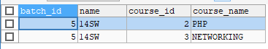

7 SELECT * FROM courses c INNER JOIN teacher_course tc ON c.`course_id`=tc.`course_id` INNER JOIN teacher t ON t.`teacher_id`=tc.`teacher_id`

WHERE T.`teacher_name`='ALI';



8 SELECT * FROM student s INNER JOIN department d ON s.`dept_id`=d.`dept_id` WHERE S.`gender`='FEMALE' AND D.`dept_name`='BS-SW';

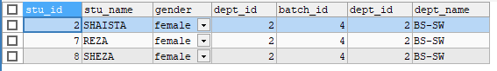

9 SELECT * FROM teacher t NATURAL JOIN department d ;

